Early Predicting of Students Performance in Higher Education
A project report submitted in partial fulfilment of the requirement for the award of degree of
BACHELOR OF TECHNOLOGY
IN
COMPUTER SCIENCE AND ENGINEERING
2022-2026
Submitted By

K. Sowmya | 2281951036
A. Premalatha | 2281951005
Minisha Rao | 2281951041
Ch. Bhavani Prasad | 2281951014
T. Ganesh | 2281951058

Under the esteemed guidance of
Mrs G. GOUTHAMI _{M. TECH(PH. D)} Assistant Professor


⬚
𝑀
.
𝑇𝐸𝐶𝐻
(
𝑃
ℎ
.
𝐷
)

DEPARTMENT OF COMPUTER SCIENCE AND ENGINEERING
Dr.B.R. AMBEDKAR UNIVERSITY,
COLLEGE OF ENGINEERING
(Srikakulam, Andhra Pradesh)

DEPARTMENT OF COMPUTER SCIENCE AND ENGINEERING
Dr.B.R. AMBEDKAR UNIVERSITY,
COLLEGE OF ENGINEERING, SRIKAKULA M
`

CERTIFICATE

This is to certify that the project entitled “EARLY PREDICTING STUDENT PERFORMANCE IN HIGHER EDUCATION” is a bonified work done by K. Sowmya(2281951036), A.Premalatha (2281951005), Minisha Rao(2281951041),CH.Bhavani Prasad(2281951014),T.Ganesh(2281951058)and This is to certify that submitted in partial fulfilment of the requirements for the award in degree of BACHELOR OF TECHNOLOGY IN COMPUTER SCIENCE AND ENGINEERING in Dr.B.R. AMBEDKAR UNIVERSITY,SRIKAKULAM,COLLEGE OF ENGINEERING is a record of Bonafide word carried out by him under our guidance and super vision.

Signature of the guide Signature of Course coordinator
Mrs G. GOUTHAMI _{M. Tech (PH. D)} Mr. P. RAMAKRISHNARAO(M. Tech)
Assistant Professor ASSISTANT PROFESSOR &
COURSE COORDINATOR

Signature of the External Examiner

DECLARATION

We hereby declare that the project work entitle “Early Predicting of Students Performance in Higher Education” submitted by us for the award of the degree of COMPUTER SCIENCE AND ENGINEERING ,under the guidance of Mrs G. GOUTHAMI _{M .Tech (PH. D)}, Assistant Professor. Dr.B.R.AMBEDKAR UNIVERSITY ,SRIKAKULAM.

K.Sowmya
Reg.No:2281951036

A.Premalatha
Reg.No.:2281951005

Minisha Rao
Place: Srikakulam Reg.No.:2281951041

Date: CH.Bhavani Prasad
Reg.No.:2281951014

T.Ganesh
Reg.No.:2281951058

ACKNOWLEDGEMENT

It is indeed with a immense sense of gratitude that we acknowledge the help of our university Administration.
We are highly indebted for the facilities provided to accomplish this mini project.
We are highly indebted to our honourable Vice-Chancellor Prof. K.R.RAJANI madam, respected Registrar Prof. P.SUJATHA madam, and our beloved Principal Prof. CH.RAJASEKHARA RAO garu for the facilities provided to accomplish this mini project.
We would like to thank our Course Coordinator Smt.B.Vyasa Geetha madam for her valuable guidance and constructive criticism throughout the project.
We feel elated in manifesting our sense of gratitude to our guide Mr.R.Sridhar sir for his extreme help throughout our project.
We are extremely grateful to our faculty, lab technicians and non-teaching staff members for their extreme help throughout the project.
Finally we express our heartful thanks to all our student friends who helped in successful completion of this project.

ABSTRACT

Students' learning performance is one of the core components for assessing any educational system. Understanding students' performance is crucial in addressing issues related to the learning process and is a key factor in measuring learning outcomes. The ability to utilize data knowledge to improve education systems has led to the development of the field of educational data mining (EDM). EDM involves creating techniques to analyze data gathered from educational settings, providing a more comprehensive and accurate understanding of students and improving educational outcomes for them.
The use of machine learning (ML) technology has significantly increased in recent years. Researchers and educators can use data mining in education to measure success, failure, dropout rates, and more, allowing for the prediction and simulation of educational processes. This work presents an analysis of students' performance using data mining methods. Both clustering and classification techniques are employed to identify the impact of various factors on students' GPA at an early stage. For the clustering technique, the paper uses a dimensionality reduction mechanism via the T-SNE algorithm, considering factors such as admission scores, first-level courses, academic achievement tests (AAT), and general aptitude tests (GAT) to explore their relationship with GPAs.

TABLE OF CONTENTS

DESCRIPTION PAGE NO.
PROJECT REPORT 1 – 2
DECLARATION 3
ACKNOWLEDGEMENT 4
ABSTRACT 5
TABLE OF CONTENTS 6 – 8
LIST OF FIGURES 9

CHAPTER - 1 10 - 13

1. INTRODUCTION
1.1 Overview
1.2 Objective
1.3 Scope

CHAPTER – 2 14 - 16 2. LITERATURE SURVEY
2.1 Prediction of Student Performance using Machine Learning
2.2 A Novel Technique to Predict the Performance of Students
2.3 Review on Prediction using the given techniques
2.4 Utilization of Machine Learning Techniques for Early Prediction in Education
CHAPTER – 3 17 - 25

3. METHODOLOGY
3.1 Aim of the Project
3.2 Existing System
3.2.1 Disadvantages of Existing System
3.3 Proposed System
3.3.1 Advantages of Proposed System
3.4 System Architecture
3.5 System Requirements
3.6 Modules Description
3.7 DataFlow Diagram
3.8 Python and its features

CHAPTER – 4 26 - 28
4.REQUIREMENT ANALYSIS
4.1 Analysis and its types.
CHAPTER – 5 29 - 33

5.DATA VISUALISATION
5.1 Density Distribution Function
5.2 Gender Comparison in Admission Criteria
5.3. Admission Scores and features
5.4 Visual Insights

CHAPTER – 6 34 - 36 6.PREPROCESSING AND FEATURE ENGINEERING
6.1 Data Cleaning
6.2 Encoding Categorical features
- 3.Scaling Numerical features
6.4 Handling missing values

CHAPTER – 7 37 - 45 7. MODELING
7.1Model Selection
7.2 Pipe-line Creation
7.3 Model Training
7.4 Model Evaluation metrics
7.5 Performance Comparision
7.6 Reference Code

CHAPTER – 8 46 - 48
- RESULTS AND DISCUSSION
  - Model Performance
  - Precession, Recall, F1 Score, Accuracy
  - Insights from Performance metrics.
  - Recommendations

CHAPTER – 9 49 - 52 9.ADDITIONAL ANALYSIS
9.1 Total Failed Students Analysis
9.2 Jaccard Similarity Network Analysis

CHAPTER – 10 53 - 55 10.CONCLUSION
10.1 Summary of Findings
10.2 Limitations
10.3 Future Work
CHAPTER – 11 56 - 57 11. REFERENCES

LIST OF FIGURES

Figure Names Page No.

3.7.a.Data Flow Diagram 23
5.1.a.Density Distribution Functions 30
5.2.a.Gender Comparison in Admission Criteria 31
5.3.a.Box Plot of Admission Scores Features 32
9.1.a.Total Failed Students in Courses (2016-2021) 50
9.1.b.Total Failed Students in Courses (2021) 51
9.2.a.Jaccard Similarity Network Graph 52

CHAPTER - 1
INTRODUCTION

INTRODUCTION

1.1 Overview
Education is a fundamental element that plays a significant role in our society. Information and communication technology has impacted many fields of research, particularly in education. For example, various e-Learning environments have been used in many countries due to the recent COVID-19 pandemic.
Higher education institutions consider the academic performance of students as one of the most important aspects of providing quality education. Understanding the significant factors influencing students' performance at an early stage of their education is complex. Various effective tools have been used to overcome the challenges of student performance in academia. However, these tools may not be easily generalised across all educational contexts.
In recent years, with the advancements in forecasting students' performance through technology, there are still gaps to be filled to analyse and improve the accuracy of students' performance using new features and data mining methods. This project presents both clustering and classification techniques to identify the impact of various factors on students' GPA at an early stage.
The learning process encompasses a lot of student performance data. Identifying students who are more likely to have poor academic success in the future requires making predictions about student performance. If the data is transformed into knowledge, it can be useful for making accurate predictions. As a result, this information can improve the quality of education and help students achieve their academic objectives. Data mining techniques are used in the study area known as educational data mining (EDM) to analyze information derived from educational settings. Implementing EDM also aids in planning strategies to enhance student performance, thereby improving teaching, learning, and the overall student experience in educational institutions.
Academic success is important because it is strongly linked to the positive outcomes we value. One of the academic success factors is students' performance in college or university. The cumulative academic achievement for each student still indicates the success of every college or university. Additionally, factors such as aptitude tests, GPA of secondary school, and the name of the school from which the student graduated can be used to analyse and predict academic performance. We believe that the performance of students in their first year of college can be used as a predictor for their performance in subsequent years. These factors can lead to early interventions and actions to improve student performance. Artificial intelligence techniques have been applied to educational data to reveal the significant reasons behind student performance.
The contributions of this project are as follows:
Framework Proposal: We propose a framework for predicting students' performance using their academic performance and social relationships features.
- Utilizing Admission Scores: We use admission scores, first-level course scores, academic achievement tests (AAT), and general aptitude tests (GAT).
- Dimensionality Reduction: We explore a new way of using admission and first-level course scores, AAT, and GAT through t-SNE dimensionality reduction. To the best of our knowledge, this is the first attempt to use features from both admission and first-level course scores to predict student performance using machine learning.
- Threshold Analysis: We explore a new method of increasing the threshold of relocating, which involves computing the absolute difference between a grade and the following grade.
- State-of-the-Art Models: We use state-of-the-art classification models to evaluate the effectiveness of our proposed ideas.

1.2 Objectives
Framework Proposal:
- Develop a comprehensive framework for predicting students' performance using their academic records and social relationships.
Utilizing Admission Scores:
- Utilize admission scores, first-level course scores, academic achievement tests (AAT), and general aptitude tests (GAT) to predict student performance.
Dimensionality Reduction:
- Explore the use of t-SNE dimensionality reduction to analyze the relationship between various factors (such as admission scores, first-level course scores, AAT, and GAT) and GPA.
- Pioneer the integration of both admission scores and first-level course scores to predict student performance at early stages using machine learning.

Machine Learning Models:
- Employ state-of-the-art classification models to evaluate the effectiveness of the proposed framework.
- Conduct experiments using different machine learning models to predict student performance using various features, including course grades and admission test scores.

Assessment Metrics:
- Use a variety of assessment metrics (such as precision, recall, F1 score, and accuracy) to evaluate the quality and performance of the machine learning models.
Early Intervention:
- Identify students who are more likely to have poor academic success in the future, enabling early interventions to improve their performance.
Educational Insights:
- Provide insights and recommendations to educational institutions for mitigating the risks of student failures at early stages.

1.3 Scope
The scope of this project involves generating a comprehensive dataset of student performance, conducting data preprocessing, exploratory data analysis, and creating visualizations to provide insights. Clustering techniques and dimensionality reduction methods are applied to explore relationships between various factors and students' GPA. State-of-the-art machine learning models are used to predict student performance, and their effectiveness is evaluated using precision, recall, F1 score, and accuracy. The project aims to enhance educational outcomes by identifying significant factors influencing student performance, enabling early interventions, and providing actionable insights for educators and policymakers. By leveraging advanced data mining and machine learning techniques, the project seeks to improve the accuracy of student performance predictions and contribute to the field of educational data mining.

CHAPTER - 2
LITERATURE SURVEY

Literature Survey

2.1 Prediction of Student Performance using Machine Learning
The prediction of student performance using machine learning has been extensively researched in recent years. Various studies have explored the application of different machine learning techniques to predict student outcomes, identify at-risk students, and enhance educational outcomes. Initial studies focused on applying machine learning techniques to distance learning for dropout prediction, paving the way for further research in this area. Other studies utilized Bayesian Classification to determine factors affecting student performance, concluding that Naive Bayes performed better than other algorithms for early prediction using initial attendance and homework grades.
Educational Data Mining (EDM) has played a significant role in advancing the learning environment by utilizing machine learning techniques to predict student performance and identify at-risk students. Overall, machine learning techniques have shown great potential in improving educational outcomes by providing early interventions and personalized support to students.

2.2 A Novel Technique to Predict the Performance of Students
In this project, a novel technique is proposed to predict student performance by utilizing a comprehensive dataset generated through a Python script. The dataset includes various attributes such as GPA, grades, test scores, and more. The methodology involves:
- Generating student data with random values to simulate real-world diversity and variability.
- Applying clustering techniques and dimensionality reduction using t-SNE to explore relationships between different factors and students' GPA.
- Using state-of-the-art classification models, including Random Forest, SVM, and Naive Bayes, to predict student performance based on various features such as admission scores, first-level course scores, academic achievement tests (AAT), and general aptitude tests (GAT).

2.3 Review on Prediction Using the Given Techniques
The given techniques for predicting student performance have been reviewed and compared against existing methods. The methodologies include clustering and classification techniques, dimensionality reduction using t-SNE, and the application of multiple machine learning models. The reviewed literature shows that these techniques are effective in identifying significant factors influencing student performance and providing accurate predictions. Various studies summarized theoretical justifications for learning analytics and applied machine learning algorithms using different datasets. These studies highlight the importance of using diverse features and advanced algorithms to enhance the accuracy of predictions.
Overall, the combination of these techniques provides a robust framework for predicting student performance.

2.4 Utilization of Machine Learning Techniques for Early Prediction in Higher Education
The utilization of machine learning techniques for early prediction in higher education has shown promising results in improving student performance and reducing dropout rates. By leveraging admission scores, first-level course scores, and test scores, machine learning models can provide early warnings for at-risk students. Studies have demonstrated the effectiveness of using machine learning algorithms such as deep neural networks, XGBoost, and logistic regression to predict academic success. These studies highlight the importance of using a combination of academic and non-academic features to enhance the accuracy of predictions and provide timely interventions.

CHAPTER - 3
METHODOLOGY

3.1 Aim of the Project
The aim of this project is to predict student performance at an early stage using machine learning techniques. This involves generating a comprehensive dataset, preprocessing it, applying machine learning algorithms, and evaluating their performance to provide insights and recommendations for educational institutions.

3.2 Existing System
The existing system for predicting student performance often relies on traditional methods such as manual assessments and basic statistical analyses. These methods may not accurately capture the complex factors influencing student performance and may lack the ability to provide timely interventions.

3.2.1 Disadvantages of Existing System
- Limited Accuracy: Traditional methods may not accurately predict student performance due to the lack of advanced analytical techniques.
- Lack of Timely Interventions: Existing systems may fail to identify at-risk students early enough to provide effective interventions.
- Inability to Handle Large Datasets: Traditional methods may struggle with the volume and complexity of modern educational data.
- Limited Insights: Basic statistical analyses may not uncover deeper insights and patterns within the data.

3.3 Proposed System
The proposed system leverages machine learning techniques to predict student performance at an early stage. It involves generating a synthetic dataset, preprocessing the data, applying clustering and classification algorithms, and evaluating their performance using various metrics.

3.3.1 Advantages of Proposed System
- Enhanced Accuracy: Machine learning algorithms provide more accurate predictions by capturing complex patterns within the data.
- Early Interventions: The system identifies at-risk students early, allowing for timely and effective interventions.
- Scalability: The proposed system can handle large and complex datasets efficiently.
- Deeper Insights: Advanced analytical techniques uncover valuable insights and patterns that traditional methods may miss.

3.4 System Architecture
The system architecture consists of the following components:
- Data Generation: A Python script generates a synthetic dataset simulating real-world student performance.
- Data Preprocessing: Preprocessing steps include data cleaning, encoding categorical features, and scaling numerical features.
- Exploratory Data Analysis (EDA): Various visualizations and analyses are performed to understand data distribution and relationships.
- Clustering and Dimensionality Reduction: Techniques like t-SNE are applied to explore relationships between different factors.
- Classification and Prediction: State-of-the-art machine learning models are used to predict student performance.
- Evaluation: Model performance is evaluated using metrics such as precision, recall, F1 score, and accuracy.

3.5 System Requirements
- Software:
◦ Python
◦ Pandas
◦ Matplotlib
◦ Seaborn
◦ Scikit-learn
◦ Networkx
- Hardware:
◦ A computer with at least 4GB RAM and a multi-core processor.

3.6 Modules Description

3.6.1 Data Constraints
• Attributes: The dataset consists of 24 attributes, including student ID, sex, campus name, course details, grades, performance indicators, and more.
Student ID |  | Sex | Campus Name | Name of the Course | Performance | Admission Criteria
 | 1 | Male | Campus A | Course2 | 1 | Merit-based
 | 2 | Female | Campus B | Course1 | 0 | Entrance Exam
… |  | … | … | … | … | …

3.6.2 Train Dataset and Test Dataset
- Training Set: 80% of the dataset is used for training the machine learning models.
- Test Set: 20% of the dataset is reserved for testing the models to evaluate their performance.

3.6.3 Pre-processing of Data
- Data Cleaning: Handling missing values and correcting inconsistencies.
- Encoding: Using OneHotEncoder to convert categorical features into numerical format.
- Scaling: Applying StandardScaler to normalize numerical features.

3.6.4 Feature Extraction
- Admission Scores: Utilized to predict student performance.
- Course Scores: Scores from first-level courses, academic achievement tests (AAT), and general aptitude tests (GAT).
- Dimensionality Reduction: Using t-SNE to reduce dimensionality and explore relationships between features and GPA.

3.6.5 ML Algorithms

Random Forest
Random Forest is a highly versatile algorithm that can be used for both classification and regression tasks. It operates by constructing a multitude of decision trees during training time and outputting either the mode of the classes (classification) or the mean prediction (regression) of the individual trees. The principle behind Random Forest is to combine the predictions of multiple decision trees to improve the overall performance and reduce the risk of overfitting. Each tree in the forest is built using a different subset of the training data and features, ensuring diversity among the trees. This ensemble method enhances the algorithm's ability to handle large datasets with higher dimensionality and provides robustness against noise and outliers in the data.

Support Vector Machine (SVM)
Support Vector Machine (SVM) is a powerful algorithm primarily used for classification tasks, especially in high-dimensional spaces. SVM aims to find the optimal hyperplane that best separates the classes in the feature space. It works by identifying the support vectors, which are the data points closest to the hyperplane, and using these support vectors to maximize the margin between the classes. This margin maximization approach ensures that the classifier achieves good generalization on unseen data. SVM is effective in handling both linear and non-linear classification problems, the latter by using kernel functions to transform the input space into a higher-dimensional space where a linear separation is possible.

Naive Bayes
Naive Bayes is a probabilistic classifier based on Bayes' theorem, which provides a way to update the probability estimate of a hypothesis given new evidence. The "naive" assumption refers to the algorithm's assumption that the features are conditionally independent, given the class label. Despite this simplifying assumption, Naive Bayes performs remarkably well in various real-world applications, particularly in text classification and spam detection. It is computationally efficient, easy to implement, and requires a small amount of training data to estimate the parameters needed for classification. Naive Bayes is particularly effective when the independence assumption holds or when the model needs to handle a large number of features.

Other Models
- Logistic Regression: Logistic Regression is a statistical model used for binary classification tasks. It estimates the probability that a given input belongs to a particular class by fitting a logistic function to the input features. The output is a value between 0 and 1, representing the predicted probability of the positive class.
- XGBoost: XGBoost, short for Extreme Gradient Boosting, is an advanced implementation of gradient boosting for supervised learning tasks. It builds an ensemble of decision trees sequentially, where each new tree corrects the errors made by the previous trees. XGBoost is known for its high performance, scalability, and efficiency, making it a popular choice for various machine learning competitions and applications.

3.7 Data Flow Diagram
The data flow diagram illustrates the flow of data through the system, from data generation to preprocessing, model training, and evaluation as follows 3.7.a.
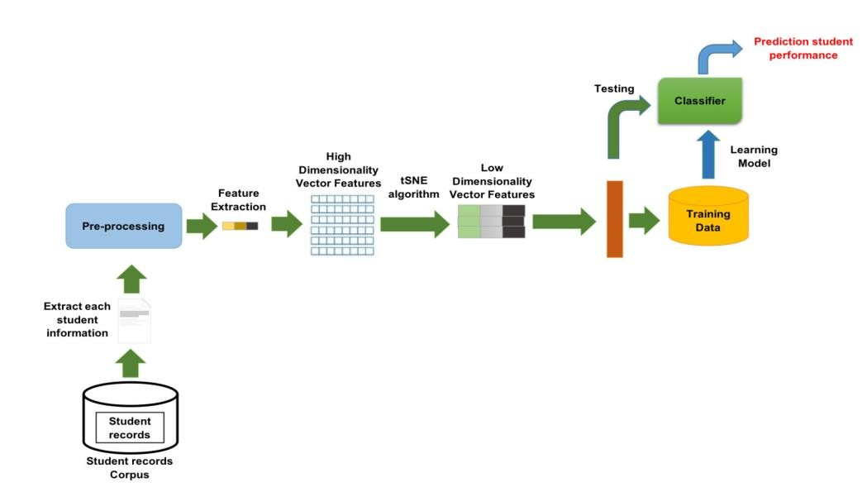

Fig.3.7.a. DataFlow Diagram

The process of predicting student performance using machine learning involves several key steps.
First, a comprehensive dataset that simulates various attributes of student performance, such as GPA, grades, and test scores. This dataset is then preprocessed to handle missing values, encode categorical features into numerical format, and scale numerical features for normalization. Exploratory data analysis (EDA) is conducted to understand the distribution and relationships within the dataset, which includes creating visualizations like density plots and line plots. Clustering techniques and dimensionality reduction methods, such as t-SNE, are applied to explore relationships between different factors and students' GPA. Multiple machine learning models, including Random Forest, SVM, and Naive Bayes, are then trained to predict student performance. The models are evaluated based on metrics like precision, recall, F1 score, and accuracy to determine their effectiveness. Finally, insights from the analysis are used to provide actionable recommendations for educational institutions, enabling early interventions for at-risk students and improving overall student outcomes. This process ensures a robust framework for predicting and enhancing student performance.

3.8 Python

3.8.1 History of Python
Python is a high-level programming language that was created by Guido van Rossum and first released in 1991. It was designed with the philosophy of code readability and simplicity in mind, making it accessible and easy to use for both beginners and experienced programmers. Python has evolved significantly over the years, with major versions like Python 2.0 released in 2000 and Python 3.0 in 2008, each introducing new features and improvements. Today, Python is one of the most popular programming languages in the world, widely used in various fields such as web development, data analysis, artificial intelligence, scientific computing, and more.

3.8.1.1 Python Features
Python boasts several features that make it a preferred choice for many developers:
- Simple and Readable Syntax: Python's syntax is clear and concise, making it easy to read and write code.
- Versatility: Python can be used for web development, data analysis, machine learning, automation, and more.
- Large Standard Library: Python comes with a comprehensive standard library that provides modules and functions for various tasks.
- Cross-Platform Compatibility: Python code can run on different operating systems, including Windows, macOS, and Linux.
- Extensive Support for Third-Party Libraries: The Python Package Index (PyPI) hosts a vast collection of third-party libraries that extend Python's capabilities.
- Strong Community Support: Python has an active and supportive community, providing numerous resources, tutorials, and forums for developers.

3.8.2 Purpose of Python in this Particular Project
Python's usefulness in this project is evident through its various strengths and capabilities:
- Data Generation and Manipulation: Python's libraries, such as random and pandas, facilitate the generation and manipulation of synthetic student performance data.
- Data Visualization: Libraries like matplotlib and seaborn are used to create insightful visualizations, helping to understand data distribution and relationships.
- Machine Learning: Python's scikit-learn library provides a robust framework for implementing machine learning algorithms, including Random Forest, SVM, and Naive Bayes, which are used for predicting student performance.
- Flexibility and Ease of Use: Python's simple syntax and readability make it easy to develop and maintain the code for this project.
- Extensive Libraries: Python's extensive libraries and frameworks support various aspects of the project, from data preprocessing to model evaluation.
- Integration and Automation: Python can integrate seamlessly with other tools and automate repetitive tasks, improving the efficiency of the project workflow.

CHAPTER - 4
REQUIREMENT ANALYSIS

4.1 Requirement Analysis
The requirement analysis involves identifying the needs and constraints of the project to ensure successful implementation. It includes gathering information on the data, tools, and techniques required for the analysis and prediction of student performance.

4.2 Functional Requirements
Functional requirements define the specific behavior or functions of the system:
- Data Generation: Generate a comprehensive dataset of student performance, including attributes such as GPA, grades, and test scores.
- Data Preprocessing: Clean and preprocess the data, including handling missing values, encoding categorical features, and scaling numerical features.
- Exploratory Data Analysis: Conduct EDA to understand data distribution and relationships, using visualizations like density plots and line plots.
- Clustering and Dimensionality Reduction: Apply clustering techniques and dimensionality reduction methods like t-SNE.
- Classification and Prediction: Implement machine learning models (Random Forest, SVM, Naive Bayes) to predict student performance.
- Model Evaluation: Evaluate model performance using precision, recall, F1 score, and accuracy.
- Insights and Recommendations: Provide actionable insights and recommendations based on the analysis.

4.3 Non-Functional Requirements
Non-functional requirements define the system's performance criteria and other attributes:
- Scalability: The system should handle large datasets efficiently.
- Accuracy: The predictions should be accurate, with high precision, recall, F1 score, and accuracy.
- Usability: The system should be user-friendly and easy to use.
- Reliability: The system should provide consistent and reliable predictions.
- Maintainability: The system should be easy to maintain and update.
- Visualization: The system should provide clear and informative visualizations to enhance understanding of the data.

CHAPTER - 5
DATA VISUALISATION

5.1 Density Distribution Functions
Density distribution functions provide insights into the distribution of student performance metrics such as test scores and grades. These visualizations help in understanding the central tendency, spread, and skewness of the data.
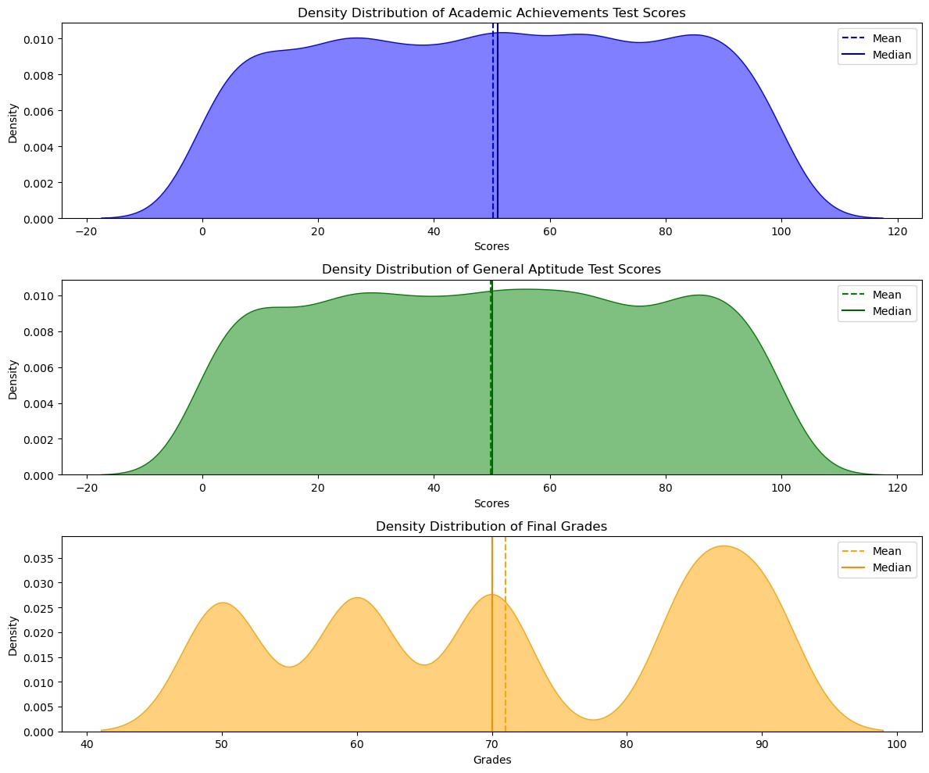
Fig.5.1.a.Density Distribution Functions

5.1.1. Academic Achievements Test Scores
The visualization of the density distribution of Academic Achievements Test Scores includes plotting the density curve and marking the mean and median lines. This helps in identifying the central values and the spread of the scores. A higher density around certain scores indicates a concentration of students achieving similar results.

5.1.2 General Aptitude Test Scores
Similarly, the density distribution of General Aptitude Test Scores is visualized with mean and median lines. This plot helps in understanding the overall performance of students in the GAT and highlights the central tendency and variability in scores. The mean and median lines provide reference points for comparing individual student scores against the average performance.

5.1.3 Final Grades
The density distribution of final grades is visualized to show the spread of grades among students. The plot includes mean and median lines to indicate the average and middle values of the grades. This visualization helps in understanding how grades are distributed across the student population and identifies any skewness in the data.

5.2 Gender Comparison in Admission Criteria
Gender comparison visualizations help in analyzing differences in performance metrics between
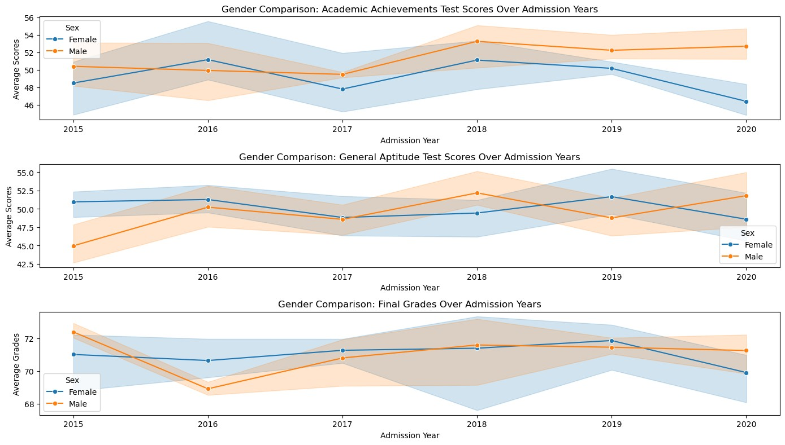
male and female students over the years.

5.2.1 Academic Achievements Test Scores
A line plot is used to compare the Academic Achievements Test Scores of male and female students over different admission years. This visualization shows trends and variations in test scores between genders, helping to identify any performance gaps.

5.2.2 General Aptitude Test Scores
The line plot for General Aptitude Test Scores compares the performance of male and female students over admission years. This plot highlights any differences in aptitude test scores between genders and tracks changes in performance over time.

5.2.3 Final Grades
A line plot is also used to compare the final grades of male and female students over admission years. This visualization provides insights into gender-based differences in final academic performance and helps in understanding trends and variations.

5.3 Admission Scores Features
Admission scores features are visualized using box plots to show the distribution of scores for different metrics.
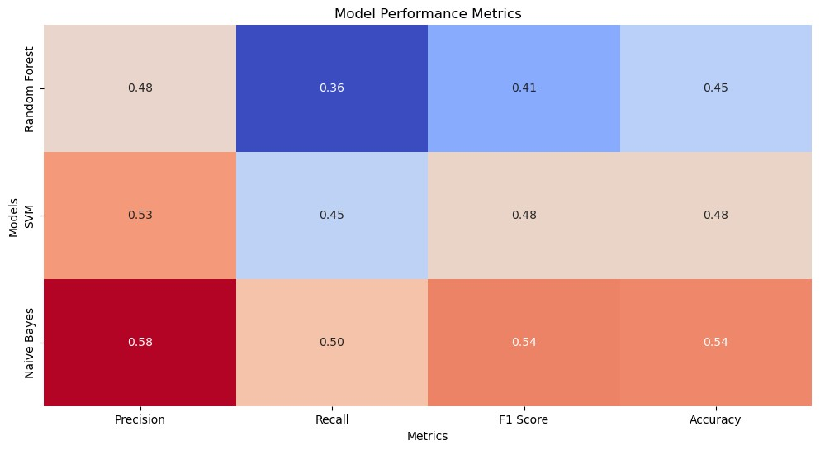

5.3.1 Box Plot
The box plot visualization includes academic achievements test scores, General Aptitude Test (GAT) scores, and final grades. Box plots provide a summary of the data distribution, including the median, quartiles, and potential outliers. This visualization helps in comparing the spread and central tendency of different performance metrics.

5.4 Visual Insights
Key insights derived from the visualizations include:
- Trends and Patterns: Identifying trends in student performance over time and across different metrics.
- Comparisons: Comparing performance between genders and different student groups.
- Central Tendency: Understanding the average performance and variability in test scores and grades.
- Outliers: Identifying students who perform significantly above or below the average.
- Skewness: Detecting any skewness in the distribution of scores and grades.

CHAPTER - 6
PREPROCESSING AND FEATURE ENGINEERING

6. Preprocessing and Feature Engineering
Preprocessing and feature engineering are crucial steps in preparing the dataset for machine learning models, ensuring that the data is clean, well-structured, and suitable for analysis.

6.1 Data Cleaning
Data cleaning involves various steps to ensure the dataset is free from inconsistencies and errors. This includes handling missing values, correcting inaccuracies, and removing any irrelevant or duplicate entries. By addressing these issues, we ensure that the data used for analysis and modeling is accurate and reliable.

6.2 Encoding Categorical Features
Categorical features, such as student gender, campus name, and course titles, need to be converted into a numerical format for machine learning algorithms to process them. This is achieved using the OneHotEncoder, which transforms categorical variables into a binary (0 or 1) format, allowing the models to interpret and use these features effectively.

6.3 Scaling Numerical Features
Numerical features, such as GPA, test scores, and grades, often have different ranges and units. To normalize these features and ensure they contribute equally to the model, we apply
StandardScaler. This technique scales the numerical data to have a mean of 0 and a standard deviation of 1, making the dataset more consistent and improving the performance of machine learning algorithms.

6.4 Handling Missing Values
Handling missing values is a critical step in data preprocessing. Various techniques can be employed to address missing data, such as:
- Imputation: Filling missing values with statistical measures like mean, median, or mode.
- Interpolation: Estimating missing values based on the surrounding data points.
- Removal: Eliminating rows or columns with missing values if the amount of missing data is substantial.
By carefully handling missing values, we ensure that the dataset remains robust and accurate, enabling more reliable predictions and analyses.
Overall, these preprocessing and feature engineering steps transform raw data into a structured and clean format, ready for machine learning models to analyze and generate accurate predictions of student performance.

CHAPTER - 7

MODELING

7.1 Model Selection
For this project, we selected three machine learning models: Random Forest, Support Vector Machine (SVM), and Naive Bayes. These models were chosen due to their proven effectiveness in classification tasks and their ability to handle diverse data types.

7.2 Pipeline Creation
We created a preprocessing and modeling pipeline using Pipeline and
ColumnTransformer from the scikit-learn library. The pipeline automates the
preprocessing steps and ensures that the transformations are consistently applied to both the training and test datasets. The pipeline includes:
- ColumnTransformer: To apply StandardScaler for scaling numerical features and OneHotEncoder for encoding categorical features.
- Pipeline Steps: Incorporating the ColumnTransformer for preprocessing and the selected machine learning model for classification.

7.3 Model Training
The model training process involves splitting the dataset into training and testing sets. We used the train_test_split function from scikit-learn to allocate 80% of the data for training and 20% for testing. The training set is used to fit the model, while the test set is used to evaluate the model's performance. The models are trained on the preprocessed data to learn the patterns and relationships between the features and the target variable.

7.4 Model Evaluation Metrics
To evaluate the performance of the models, we used the following metrics:
- Precision: The ratio of true positive predictions to the total predicted positives. It indicates the accuracy of the positive predictions.
- Recall: The ratio of true positive predictions to the total actual positives. It measures the model's ability to identify all relevant instances.
- F1 Score: The harmonic mean of precision and recall, providing a balanced measure of the model's performance.
- Accuracy: The ratio of correctly predicted instances to the total instances. It gives an overall measure of the model's performance.

7.5 Performance Comparison

We visualized the performance of the different models using a heatmap. The heatmap compares the precision, recall, F1 score, and accuracy of the Random Forest, SVM, and Naive Bayes models. This visualization helps in identifying the best-performing model and understanding the strengths and weaknesses of each model in terms of various evaluation metrics.
7.6 Start Coding & Run Your Project
7.6.1 Install Software
- Install Python (from python.org)
- Install VS Code
- Open VS Code → Install extension:
- Python Extension (by Microsoft)
Create Project Folder
- Create a folder (example: student_performance)
- Open that folder in VS Code
Create Python File
- Click New File
- Name it:
main.py
Install Required Libraries
Open terminal in VS Code and run:
</>bash
pip install pandas numpy scikit-learn matplotlib

This section outlines the step-by-step process to be followed for developing the project.
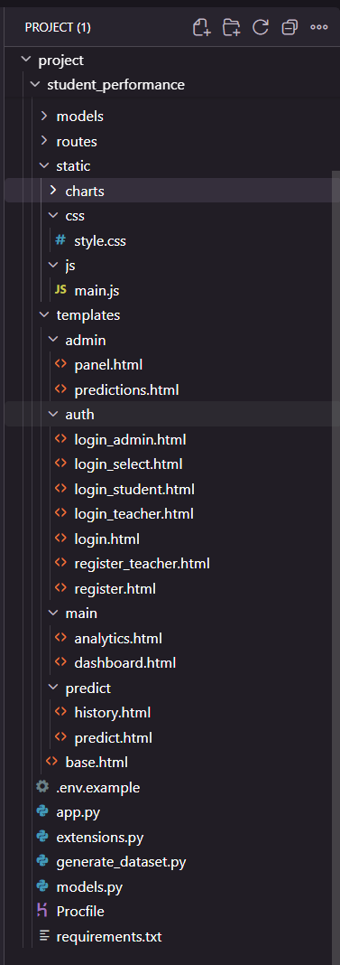
login_student.html
<!DOCTYPE html>
<html lang="en">
<head>
<meta charset="UTF-8"/>
<meta name="viewport" content="width=device-width, initial-scale=1.0"/>
<title>Student Login | EduPredict</title>
<link rel="stylesheet" href="https://cdnjs.cloudflare.com/ajax/libs/font-awesome/6.4.0/css/all.min.css"/>
<link rel="stylesheet" href="{{ url_for('static', filename='css/style.css') }}"/>
<style>
.auth-body { min-height: 100vh; display: flex; align-items: stretch; }
.auth-left { flex: 1; background: linear-gradient(135deg, #1a237e 0%, #3f51b5 100%);
display: flex; flex-direction: column; justify-content: center; padding: 60px 48px; color: #fff; }
.auth-brand { display: flex; align-items: center; gap: 14px; margin-bottom: 16px; }
.auth-brand i { font-size: 2.4rem; }
.auth-brand h1 { font-size: 2rem; font-weight: 700; }
.auth-tagline { font-size: 1.05rem; opacity: 0.9; margin-bottom: 8px; }
.auth-sub { font-size: 0.85rem; opacity: 0.65; margin-bottom: 40px; }
.auth-features { display: flex; flex-direction: column; gap: 14px; }
.feature-item { display: flex; align-items: center; gap: 12px; font-size: 0.95rem; opacity: 0.85; }
.feature-item i { width: 20px; text-align: center; }
.auth-right { flex: 1; display: flex; align-items: center; justify-content: center;
background: #f0f2f5; padding: 40px 24px; }
.auth-card { background: #fff; border-radius: 16px; padding: 40px 36px; width: 100%; max-width: 400px;
box-shadow: 0 4px 24px rgba(0,0,0,0.08); }
.auth-card h2 { font-size: 1.6rem; color: #1a237e; margin-bottom: 4px; }
.auth-card-sub { color: #757575; margin-bottom: 28px; font-size: 0.9rem; }
.role-badge { display: inline-flex; align-items: center; gap: 6px; background: #e8eaf6;
color: #1a237e; border-radius: 20px; padding: 4px 14px; font-size: 0.8rem;
font-weight: 600; margin-bottom: 20px; }
.form-group { margin-bottom: 18px; }
.form-group label { display: block; font-weight: 600; margin-bottom: 6px; color: #424242; font-size: 0.88rem; }
.form-group label i { margin-right: 6px; color: #1a237e; }
.form-control { width: 100%; padding: 10px 14px; border: 1.5px solid #e0e0e0; border-radius: 8px;
font-size: 0.95rem; transition: border-color 0.2s; outline: none; }
.form-control:focus { border-color: #3f51b5; }
.input-eye { position: relative; }
.input-eye .form-control { padding-right: 42px; }
.input-eye button { position: absolute; right: 12px; top: 50%; transform: translateY(-50%);
background: none; border: none; cursor: pointer; color: #9e9e9e; }
.form-check { display: flex; align-items: center; gap: 8px; margin-bottom: 20px; font-size: 0.88rem; }
.btn-primary { width: 100%; padding: 12px; background: #1a237e; color: #fff; border: none;
border-radius: 8px; font-size: 1rem; font-weight: 600; cursor: pointer; transition: background 0.2s; }
.btn-primary:hover { background: #283593; }
.auth-switch { text-align: center; margin-top: 20px; font-size: 0.88rem; color: #757575; }
.auth-switch a { color: #1a237e; font-weight: 600; text-decoration: none; }
.back-link { display: inline-flex; align-items: center; gap: 6px; color: rgba(255,255,255,0.7);
text-decoration: none; font-size: 0.88rem; margin-bottom: 32px; transition: color 0.2s; }
.back-link:hover { color: #fff; }
.alert { padding: 10px 14px; border-radius: 8px; margin-bottom: 16px; font-size: 0.88rem; }
.alert-danger { background: #ffebee; color: #c62828; border-left: 3px solid #c62828; }
.alert-success { background: #e8f5e9; color: #2e7d32; border-left: 3px solid #2e7d32; }
@media (max-width: 768px) { .auth-left { display: none; } }
</style>
</head>
<body class="auth-body">
<div class="auth-left">
<a href="{{ url_for('auth.login') }}" class="back-link">
<i class="fas fa-arrow-left"></i> Back to portal selection
</a>
<div class="auth-brand">
<i class="fas fa-graduation-cap"></i>
<h1>EduPredict</h1>
</div>
<p class="auth-tagline">Early Student Performance Prediction System</p>
<p class="auth-sub">Powered by Machine Learning · Based on IEEE Research</p>
<div class="auth-features">
<div class="feature-item"><i class="fas fa-chart-line"></i> View your performance predictions</div>
<div class="feature-item"><i class="fas fa-history"></i> Track prediction history</div>
<div class="feature-item"><i class="fas fa-file-pdf"></i> Download PDF reports</div>
<div class="feature-item"><i class="fas fa-shield-alt"></i> Secure student portal</div>
</div>
</div>

<div class="auth-right">
<div class="auth-card">
<div class="role-badge"><i class="fas fa-user-graduate"></i> Student Portal</div>
<h2>Student Login</h2>
<p class="auth-card-sub">Sign in to your student account</p>

{% with messages = get_flashed_messages(with_categories=true) %}
{% if messages %}{% for category, message in messages %}
<div class="alert alert-{{ category }}">{{ message }}</div>
{% endfor %}{% endif %}
{% endwith %}

<form method="POST" action="{{ url_for('auth.login_student') }}">
<div class="form-group">
<label><i class="fas fa-user"></i> Username</label>
<input type="text" name="username" class="form-control" placeholder="Enter your username" required/>
</div>
<div class="form-group">
<label><i class="fas fa-lock"></i> Password</label>
<div class="input-eye">
<input type="password" name="password" id="loginPass" class="form-control" placeholder="Enter your password" required/>
<button type="button" onclick="togglePass('loginPass')"><i class="fas fa-eye"></i></button>
</div>
</div>
<div class="form-check">
<input type="checkbox" name="remember" id="remember"/>
<label for="remember">Remember me</label>
</div>
<button type="submit" class="btn-primary">
<i class="fas fa-sign-in-alt"></i> Sign In as Student
</button>
</form>
<p class="auth-switch">Don't have an account? <a href="{{ url_for('auth.register') }}">Register</a></p>
<p class="auth-hint" style="text-align:center;margin-top:10px;font-size:0.8rem;color:#9e9e9e;">
<i class="fas fa-info-circle"></i> Test: <strong>student1 / student123</strong>
</p>
</div>
</div>
</body>
<script>
function togglePass(id) {
const el = document.getElementById(id);
el.type = el.type === 'password' ? 'text' : 'password';
}
</script>
</html>

Output:-
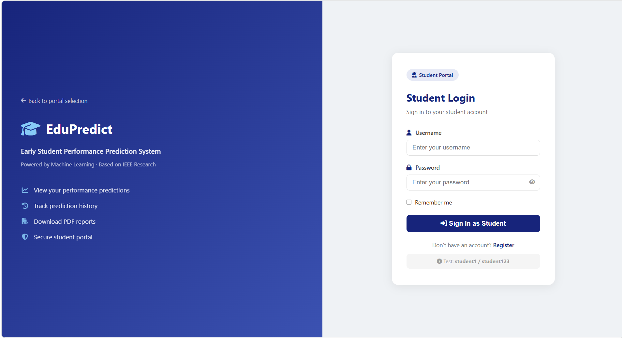
register.html
<!DOCTYPE html>
<html lang="en">
<head>
<meta charset="UTF-8"/>
<meta name="viewport" content="width=device-width, initial-scale=1.0"/>
<title>Register | EduPredict</title>
<link rel="stylesheet" href="https://cdnjs.cloudflare.com/ajax/libs/font-awesome/6.4.0/css/all.min.css"/>
<link rel="stylesheet" href="{{ url_for('static', filename='css/style.css') }}"/>
</head>
<body class="auth-body">
<div class="auth-container">
<div class="auth-left">
<div class="auth-brand">
<i class="fas fa-graduation-cap"></i>
<h1>EduPredict</h1>
</div>
<p class="auth-tagline">Join the Early Prediction Platform</p>
<p class="auth-sub">Help students succeed with data-driven insights</p>
<div class="auth-features">
<div class="feature-item"><i class="fas fa-user-plus"></i> Free Registration</div>
<div class="feature-item"><i class="fas fa-lock"></i> Secure & Private</div>
<div class="feature-item"><i class="fas fa-infinity"></i> Unlimited Predictions</div>
</div>
</div>
<div class="auth-right">
<div class="auth-card">
<h2>Create Account</h2>
<p class="auth-card-sub">Fill in your details below</p>

{% with messages = get_flashed_messages(with_categories=true) %}
{% if messages %}
{% for category, message in messages %}
<div class="alert alert-{{ category }}">{{ message }}</div>
{% endfor %}
{% endif %}
{% endwith %}

<form method="POST" action="{{ url_for('auth.register') }}">
<div class="form-group">
<label><i class="fas fa-user"></i> Username</label>
<input type="text" name="username" class="form-control" placeholder="Choose a username" required/>
</div>
<div class="form-group">
<label><i class="fas fa-envelope"></i> Email</label>
<input type="email" name="email" class="form-control" placeholder="Enter your email" required/>
</div>
<div class="form-group">
<label><i class="fas fa-lock"></i> Password</label>
<div class="input-eye">
<input type="password" name="password" id="regPass" class="form-control" placeholder="Create password" required/>
<button type="button" onclick="togglePass('regPass')"><i class="fas fa-eye"></i></button>
</div>
</div>
<div class="form-group">
<label><i class="fas fa-lock"></i> Confirm Password</label>
<input type="password" name="confirm_password" class="form-control" placeholder="Confirm password" required/>
</div>
<button type="submit" class="btn btn-primary btn-full">
<i class="fas fa-user-plus"></i> Create Account
</button>
</form>
<p class="auth-switch">Already have an account? <a href="{{ url_for('auth.login') }}">Sign In</a></p>
</div>
</div>
</div>
<script>
function togglePass(id) {
const el = document.getElementById(id);
el.type = el.type === 'password' ? 'text' : 'password';
}
</script>
</body>
</html>
Output:-


login_admin.html
<!DOCTYPE html>
<html lang="en">
<head>
<meta charset="UTF-8"/>
<meta name="viewport" content="width=device-width, initial-scale=1.0"/>
<title>Admin Login | EduPredict</title>
<link rel="stylesheet" href="https://cdnjs.cloudflare.com/ajax/libs/font-awesome/6.4.0/css/all.min.css"/>
<link rel="stylesheet" href="{{ url_for('static', filename='css/style.css') }}"/>
<style>
.auth-body { min-height: 100vh; display: flex; align-items: stretch; }
.auth-left { flex: 1; background: linear-gradient(135deg, #1a1a2e 0%, #16213e 60%, #0f3460 100%);
display: flex; flex-direction: column; justify-content: center; padding: 60px 48px; color: #fff; }
.auth-brand { display: flex; align-items: center; gap: 14px; margin-bottom: 16px; }
.auth-brand i { font-size: 2.4rem; color: #e94560; }
.auth-brand h1 { font-size: 2rem; font-weight: 700; }
.auth-tagline { font-size: 1.05rem; opacity: 0.9; margin-bottom: 8px; }
.auth-sub { font-size: 0.85rem; opacity: 0.65; margin-bottom: 40px; }
.auth-features { display: flex; flex-direction: column; gap: 14px; }
.feature-item { display: flex; align-items: center; gap: 12px; font-size: 0.95rem; opacity: 0.85; }
.feature-item i { width: 20px; text-align: center; color: #e94560; }
.auth-right { flex: 1; display: flex; align-items: center; justify-content: center;
background: #f0f2f5; padding: 40px 24px; }
.auth-card { background: #fff; border-radius: 16px; padding: 40px 36px; width: 100%; max-width: 400px;
box-shadow: 0 4px 24px rgba(0,0,0,0.08); }
.auth-card h2 { font-size: 1.6rem; color: #0f3460; margin-bottom: 4px; }
.auth-card-sub { color: #757575; margin-bottom: 28px; font-size: 0.9rem; }
.role-badge { display: inline-flex; align-items: center; gap: 6px; background: #fce4ec;
color: #c62828; border-radius: 20px; padding: 4px 14px; font-size: 0.8rem;
font-weight: 600; margin-bottom: 20px; }
.form-group { margin-bottom: 18px; }
.form-group label { display: block; font-weight: 600; margin-bottom: 6px; color: #424242; font-size: 0.88rem; }
.form-group label i { margin-right: 6px; color: #0f3460; }
.form-control { width: 100%; padding: 10px 14px; border: 1.5px solid #e0e0e0; border-radius: 8px;
font-size: 0.95rem; transition: border-color 0.2s; outline: none; }
.form-control:focus { border-color: #e94560; }
.input-eye { position: relative; }
.input-eye .form-control { padding-right: 42px; }
.input-eye button { position: absolute; right: 12px; top: 50%; transform: translateY(-50%);
background: none; border: none; cursor: pointer; color: #9e9e9e; }
.form-check { display: flex; align-items: center; gap: 8px; margin-bottom: 20px; font-size: 0.88rem; }
.btn-admin { width: 100%; padding: 12px; background: #0f3460; color: #fff; border: none;
border-radius: 8px; font-size: 1rem; font-weight: 600; cursor: pointer; transition: background 0.2s; }
.btn-admin:hover { background: #1a1a2e; }
.auth-switch { text-align: center; margin-top: 20px; font-size: 0.88rem; color: #757575; }
.auth-switch a { color: #0f3460; font-weight: 600; text-decoration: none; }
.back-link { display: inline-flex; align-items: center; gap: 6px; color: rgba(255,255,255,0.7);
text-decoration: none; font-size: 0.88rem; margin-bottom: 32px; transition: color 0.2s; }
.back-link:hover { color: #fff; }
.alert { padding: 10px 14px; border-radius: 8px; margin-bottom: 16px; font-size: 0.88rem; }
.alert-danger { background: #ffebee; color: #c62828; border-left: 3px solid #c62828; }
.alert-success { background: #e8f5e9; color: #2e7d32; border-left: 3px solid #2e7d32; }
.auth-hint { text-align: center; margin-top: 12px; font-size: 0.8rem; color: #9e9e9e; }
@media (max-width: 768px) { .auth-left { display: none; } }
</style>
</head>
<body class="auth-body">
<div class="auth-left">
<a href="{{ url_for('auth.login') }}" class="back-link">
<i class="fas fa-arrow-left"></i> Back to portal selection
</a>
<div class="auth-brand">
<i class="fas fa-shield-alt"></i>
<h1>EduPredict</h1>
</div>
<p class="auth-tagline">System Administration Portal</p>
<p class="auth-sub">Restricted access — authorised personnel only</p>
<div class="auth-features">
<div class="feature-item"><i class="fas fa-users-cog"></i> Full User Management</div>
<div class="feature-item"><i class="fas fa-cogs"></i> Model Training & Control</div>
<div class="feature-item"><i class="fas fa-chart-bar"></i> System-wide Analytics</div>
<div class="feature-item"><i class="fas fa-database"></i> All Predictions Access</div>
</div>
</div>

<div class="auth-right">
<div class="auth-card">
<div class="role-badge"><i class="fas fa-shield-alt"></i> Admin Portal</div>
<h2>Admin Login</h2>
<p class="auth-card-sub">Sign in with your administrator credentials</p>
{% with messages = get_flashed_messages(with_categories=true) %}
{% if messages %}{% for category, message in messages %}
<div class="alert alert-{{ category }}">{{ message }}</div>
{% endfor %}{% endif %}
{% endwith %}
<form method="POST" action="{{ url_for('auth.login_admin') }}">
<div class="form-group">
<label><i class="fas fa-user-shield"></i> Admin Username</label>
<input type="text" name="username" class="form-control" placeholder="Enter admin username" required/>
</div>
<div class="form-group">
<label><i class="fas fa-lock"></i> Password</label>
<div class="input-eye">
<input type="password" name="password" id="loginPass" class="form-control"
placeholder="Enter password" required/>
<button type="button" onclick="togglePass('loginPass')"><i class="fas fa-eye"></i></button>
</div>
</div>
<div class="form-check">
<input type="checkbox" name="remember" id="remember"/>
<label for="remember">Remember me</label>
</div>
<button type="submit" class="btn-admin">
<i class="fas fa-sign-in-alt"></i> Sign In as Admin
</button>
</form>
<p class="auth-switch"><a href="{{ url_for('auth.login') }}">← Back to portal selection</a></p>
<p class="auth-hint"><i class="fas fa-info-circle"></i> Default: <strong>admin / admin123</strong></p>
</div>
</div>
</body>
<script>
function togglePass(id) {
const el = document.getElementById(id);
el.type = el.type === 'password' ? 'text' : 'password';
}
</script>
</html>

login_select.html
<!DOCTYPE html>
<html lang="en">
<head>
<meta charset="UTF-8"/>
<meta name="viewport" content="width=device-width, initial-scale=1.0"/>
<title>Login | EduPredict</title>
<link rel="stylesheet" href="https://cdnjs.cloudflare.com/ajax/libs/font-awesome/6.4.0/css/all.min.css"/>
<link rel="stylesheet" href="{{ url_for('static', filename='css/style.css') }}"/>
<style>
.select-body { min-height: 100vh; display: flex; align-items: center; justify-content: center;
background: linear-gradient(135deg, #1a237e 0%, #283593 50%, #3f51b5 100%); }
.select-card { background: #fff; border-radius: 20px; padding: 48px 40px; text-align: center;
box-shadow: 0 20px 60px rgba(0,0,0,0.25); max-width: 600px; width: 92%; }
.select-brand { color: #1a237e; margin-bottom: 8px; }
.select-brand i { font-size: 2.5rem; }
.select-brand h1 { font-size: 2rem; font-weight: 700; margin-top: 8px; }
.select-tagline { color: #757575; margin-bottom: 36px; font-size: 0.95rem; }
.role-options { display: flex; gap: 16px; justify-content: center; flex-wrap: wrap; }
.role-btn { flex: 1; min-width: 150px; max-width: 170px; padding: 28px 16px; border-radius: 16px;
border: 2px solid transparent; text-decoration: none; transition: all 0.25s ease;
display: flex; flex-direction: column; align-items: center; gap: 12px;
font-weight: 600; font-size: 1rem; }
.role-btn i { font-size: 2.2rem; }
.role-btn span { font-size: 0.78rem; font-weight: 400; opacity: 0.75; }
.role-btn.student { background: #e8eaf6; color: #1a237e; border-color: #c5cae9; }
.role-btn.student:hover { background: #1a237e; color: #fff; border-color: #1a237e;
transform: translateY(-4px); box-shadow: 0 8px 24px rgba(26,35,126,0.3); }
.role-btn.teacher { background: #e8f5e9; color: #2e7d32; border-color: #c8e6c9; }
.role-btn.teacher:hover { background: #2e7d32; color: #fff; border-color: #2e7d32;
transform: translateY(-4px); box-shadow: 0 8px 24px rgba(46,125,50,0.3); }
.role-btn.admin { background: #e8eaf6; color: #0f3460; border-color: #b0bec5; }
.role-btn.admin:hover { background: #0f3460; color: #fff; border-color: #0f3460;
transform: translateY(-4px); box-shadow: 0 8px 24px rgba(15,52,96,0.3); }
</style>
</head>
<body class="select-body">
<div class="select-card">
<div class="select-brand">
<i class="fas fa-graduation-cap"></i>
<h1>EduPredict</h1>
</div>
<p class="select-tagline">Early Student Performance Prediction System</p>
<div class="role-options">
<a href="{{ url_for('auth.login_student') }}" class="role-btn student">
<i class="fas fa-user-graduate"></i>
Student
<span>Access your predictions</span>
</a>
<a href="{{ url_for('auth.login_teacher') }}" class="role-btn teacher">
<i class="fas fa-chalkboard-teacher"></i>
Teacher
<span>Manage & analyse students</span>
</a>
<a href="{{ url_for('auth.login_admin') }}" class="role-btn admin">
<i class="fas fa-shield-alt"></i>
Admin
<span>System administration</span>
</a>
</div>
</div>
</body>
</html>

Dashboard.html
{% extends "base.html" %}
<div class="stat-value">{{ total_preds }}</div>
<div class="stat-label">Total Predictions</div>
</div>
</div>
<div class="stat-card green">
<div class="stat-icon"><i class="fas fa-check-circle"></i></div>
<div class="stat-info">
<div class="stat-value">{{ pass_count }}</div>
<div class="stat-label">Pass Predictions</div>
</div>
</div>
<div class="stat-card red">
<div class="stat-icon"><i class="fas fa-times-circle"></i></div>
<div class="stat-info">
<div class="stat-value">{{ fail_count }}</div>
<div class="stat-label">Fail Predictions</div>
</div>
</div>
<div class="stat-card purple">
<div class="stat-icon"><i class="fas fa-percentage"></i></div>
<div class="stat-info">
<div class="stat-value">
{% if total_preds > 0 %}{{ ((pass_count / total_preds) * 100)|round(1) }}%{% else %}—{% endif %}
</div>
<div class="stat-label">Pass Rate</div>
</div>
</div>
</div>

<div class="grid-2">
<!-- Model Performance -->
<div class="card">
<div class="card-header">
<h3><i class="fas fa-robot"></i> Model Performance</h3>
<a href="{{ url_for('main.analytics') }}" class="btn btn-sm btn-outline">View All</a>
</div>
<div class="card-body">
{% if model_results %}
{% set models = ['Random Forest', 'SVM', 'Naive Bayes'] %}
{% for m in models %}
{% if model_results[m] is defined %}
<div class="model-row">
<div class="model-name">
{{ m }}
{% if model_results.best_model == m %}
<span class="badge-best">Best</span>
{% endif %}
</div>
<div class="model-bar-wrap">
<div class="model-bar" style="width: {{ model_results[m].accuracy }}%"></div>
</div>
<div class="model-score">{{ model_results[m].accuracy }}%</div>
</div>
{% endif %}
{% endfor %}
{% else %}
<div class="empty-state">
<i class="fas fa-exclamation-circle"></i>
<p>Models not trained yet.</p>
{% if current_user.is_admin() %}
<a href="{{ url_for('admin.panel') }}" class="btn btn-primary btn-sm">Train Now</a>
{% endif %}
</div>
{% endif %}
</div>
</div>

<!-- Pass/Fail Doughnut -->
<div class="card">
<div class="card-header">
<h3><i class="fas fa-chart-pie"></i> Prediction Distribution</h3>
</div>
<div class="card-body chart-container-sm">
<canvas id="doughnutChart"></canvas>
</div>
</div>
</div>

<!-- Recent Predictions -->
<div class="card mt-4">
<div class="card-header">
<h3><i class="fas fa-history"></i> Recent Predictions</h3>
<a href="{{ url_for('predict.history') }}" class="btn btn-sm btn-outline">View All</a>
</div>
<div class="card-body">
{% if recent_preds %}
<table class="data-table">
<thead>
<tr>
<th>Student</th><th>Result</th><th>Confidence</th><th>Date</th><th>Action</th>
</tr>
</thead>
<tbody>
{% for p in recent_preds %}
<tr>
<td>{{ p.student_name }}</td>
<td><span class="badge badge-{{ 'success' if p.result == 'Pass' else 'danger' }}">{{ p.result }}</span></td>
<td>{{ p.confidence }}%</td>
<td>{{ p.created_at.strftime('%b %d, %Y') }}</td>
<td>
<a href="{{ url_for('predict.download_report', pred_id=p.id) }}" class="btn btn-xs btn-outline">
<i class="fas fa-file-pdf"></i> PDF
</a>
</td>
</tr>
{% endfor %}
</tbody>
</table>
{% else %}
<div class="empty-state">
<i class="fas fa-inbox"></i>
<p>No predictions yet. <a href="{{ url_for('predict.predict') }}">Make your first prediction</a></p>
</div>
{% endif %}
</div>
</div>
{% endblock %}

{% block extra_js %}
<script>
const passCount = {{ pass_count }};
const failCount = {{ fail_count }};
const ctx = document.getElementById('doughnutChart');
if (ctx) {
new Chart(ctx, {
type: 'doughnut',
data: {
labels: ['Pass', 'Fail'],
datasets: [{
data: [passCount, failCount],
backgroundColor: ['#4caf50', '#f44336'],
borderWidth: 0,
hoverOffset: 8,
}]
},
options: {
responsive: true,
maintainAspectRatio: false,
plugins: {
legend: { position: 'bottom' },
tooltip: {
callbacks: {
label: ctx => ` ${ctx.label}: ${ctx.raw} (${((ctx.raw/(passCount+failCount||1))*100).toFixed(1)}%)`
}
}
},
cutout: '65%',
}
});
}
</script>
{% endblock %}

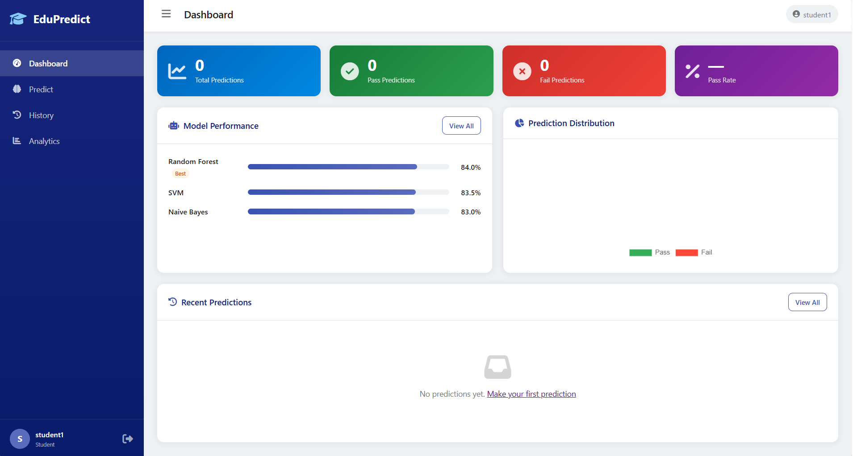
Predict.html
{% extends "base.html" %}
{% block title %}Predict{% endblock %}
{% block page_title %}Student Performance Prediction{% endblock %}

{% block content %}
<div class="grid-predict">
<!-- Input Form -->
<div class="card">
<div class="card-header">
<h3><i class="fas fa-brain"></i> Enter Student Data</h3>
</div>
<div class="card-body">
<form method="POST" action="{{ url_for('predict.predict') }}" id="predictForm">
<div class="form-group">
<label>Student Name (optional)</label>
<input type="text" name="student_name" class="form-control" placeholder="e.g. your name"/>
</div>

<div class="form-row-2">
<div class="form-group">
<label>Gender</label>
<select name="gender" class="form-control">
<option value="Male">Male</option>
<option value="Female">Female</option>
</select>
</div>
<div class="form-group">
<label>Major</label>
<select name="major" class="form-control">
<option value="CS">Computer Science</option>
<option value="IT">Information Technology</option>
<option value="CNET">Computer Networks</option>
</select>
</div>
</div>

<div class="section-divider">Admission Scores</div>
<div class="form-row-3">
<div class="form-group">
<label>AAT Score <span class="hint">(0–100)</span></label>
<input type="number" name="aat_score" class="form-control" min="0" max="100" step="0.1" placeholder="0" required/>
</div>
<div class="form-group">
<label>GAT Score <span class="hint">(0–100)</span></label>
<input type="number" name="gat_score" class="form-control" min="0" max="100" step="0.1" placeholder="0" required/>
</div>
<div class="form-group">
<label>GPA <span class="hint">(0–100)</span></label>
<input type="number" name="hs_gpa" class="form-control" min="0" max="100" step="0.1" placeholder="0" required/>
</div>
</div>
<div class="form-group">
<label>Aptitude Score <span class="hint">(composite, 0–100)</span></label>
<input type="number" name="aptitude" class="form-control" min="0" max="100" step="0.1" placeholder="0" required/>
</div>

<div class="section-divider">First-Level Course Scores</div>
<div class="form-row-3">
<div class="form-group">
<label>Math Score</label>
<input type="number" name="math_score" class="form-control" min="0" max="100" step="0.1" placeholder="0" required/>
</div>
<div class="form-group">
<label>Reading Score</label>
<input type="number" name="reading_score" class="form-control" min="0" max="100" step="0.1" placeholder="0" required/>
</div>
<div class="form-group">
<label>Writing Score</label>
<input type="number" name="writing_score" class="form-control" min="0" max="100" step="0.1" placeholder="0" required/>
</div>
</div>
<div class="form-row-2">
<div class="form-group">
<label>CS Score</label>
<input type="number" name="cs_score" class="form-control" min="0" max="100" step="0.1" placeholder="0" required/>
</div>
<div class="form-group">
<label>Physics Score</label>
<input type="number" name="physics_score" class="form-control" min="0" max="100" step="0.1" placeholder="0" required/>
</div>
</div>

<button type="submit" class="btn btn-primary btn-full" id="submitBtn">
<i class="fas fa-magic"></i> Predict Performance
</button>
</form>
</div>
</div>

<!-- Result Panel -->
<div>
{% if result %}
<div class="card result-card {{ 'result-pass' if result.prediction == 'Pass' else 'result-fail' }}">
<div class="result-icon">
<i class="fas fa-{{ 'check-circle' if result.prediction == 'Pass' else 'times-circle' }}"></i>
</div>
<div class="result-label">{{ result.prediction }}</div>
<div class="result-name">{{ student_name }}</div>
<div class="result-confidence">Confidence: {{ result.confidence }}%</div>

<!-- Probability bars -->
<div class="prob-bars">
<div class="prob-row">
<span>Pass</span>
<div class="prob-bar-wrap">
<div class="prob-bar pass-bar" style="width: {{ result.pass_prob }}%"></div>
</div>
<span>{{ result.pass_prob }}%</span>
</div>
<div class="prob-row">
<span>Fail</span>
<div class="prob-bar-wrap">
<div class="prob-bar fail-bar" style="width: {{ result.fail_prob }}%"></div>
</div>
<span>{{ result.fail_prob }}%</span>
</div>
</div>

<!-- Gauge chart -->
<canvas id="gaugeChart" height="160"></canvas>

{% if pred_id %}
<a href="{{ url_for('predict.download_report', pred_id=pred_id) }}"
class="btn btn-outline btn-full mt-2">
<i class="fas fa-file-pdf"></i> Download PDF Report
</a>
{% endif %}
</div>

<!-- Suggestions -->
{% if recommendations %}
<div class="card mt-4">
<div class="card-header">
<h3><i class="fas fa-lightbulb"></i> Performance Suggestions</h3>
</div>
<div class="card-body suggestions-body">
{% for level, title, detail in recommendations %}
<div class="suggestion-item suggestion-{{ level }}">
<div class="suggestion-icon">
<i class="fas fa-{% if level == 'success' %}check-circle{% elif level == 'danger' %}exclamation-circle{% elif level == 'warning' %}exclamation-triangle{% else %}info-circle{% endif %}"></i>
</div>
<div class="suggestion-content">
<div class="suggestion-title">{{ title }}</div>
<div class="suggestion-detail">{{ detail }}</div>
</div>
</div>
{% endfor %}
</div>
</div>
{% endif %}

{% else %}
<div class="card info-card">
<div class="info-icon"><i class="fas fa-info-circle"></i></div>
<h3>How It Works</h3>
<ol class="how-list">
<li>Enter the student's admission scores (AAT, GAT, HS GPA)</li>
<li>Enter first-level course scores</li>
<li>Click <strong>Predict Performance</strong></li>
<li>Get instant Pass/Fail prediction with confidence</li>
<li>Download a detailed PDF report</li>
</ol>
<div class="info-note">
<i class="fas fa-flask"></i>
Based on Alhazmi & Sheneamer (2023) IEEE Access research using
Random Forest, SVM, and Naive Bayes classifiers.
</div>
</div>
{% endif %}
</div>
</div>
{% endblock %}

{% block extra_js %}
{% if result %}
<script>
// Gauge-style doughnut
const gCtx = document.getElementById('gaugeChart');
if (gCtx) {
new Chart(gCtx, {
type: 'doughnut',
data: {
datasets: [{
data: [{{ result.pass_prob }}, {{ result.fail_prob }}],
backgroundColor: ['#4caf50', '#f44336'],
borderWidth: 0,
}]
},
options: {
responsive: true,
cutout: '75%',
rotation: -90,
circumference: 180,
plugins: {
legend: { display: false },
tooltip: { enabled: false },
}
}
});
}

document.getElementById('predictForm').addEventListener('submit', () => {
const btn = document.getElementById('submitBtn');
btn.innerHTML = '<i class="fas fa-spinner fa-spin"></i> Predicting...';
btn.disabled = true;
});
</script>
{% endif %}
{% endblock %}
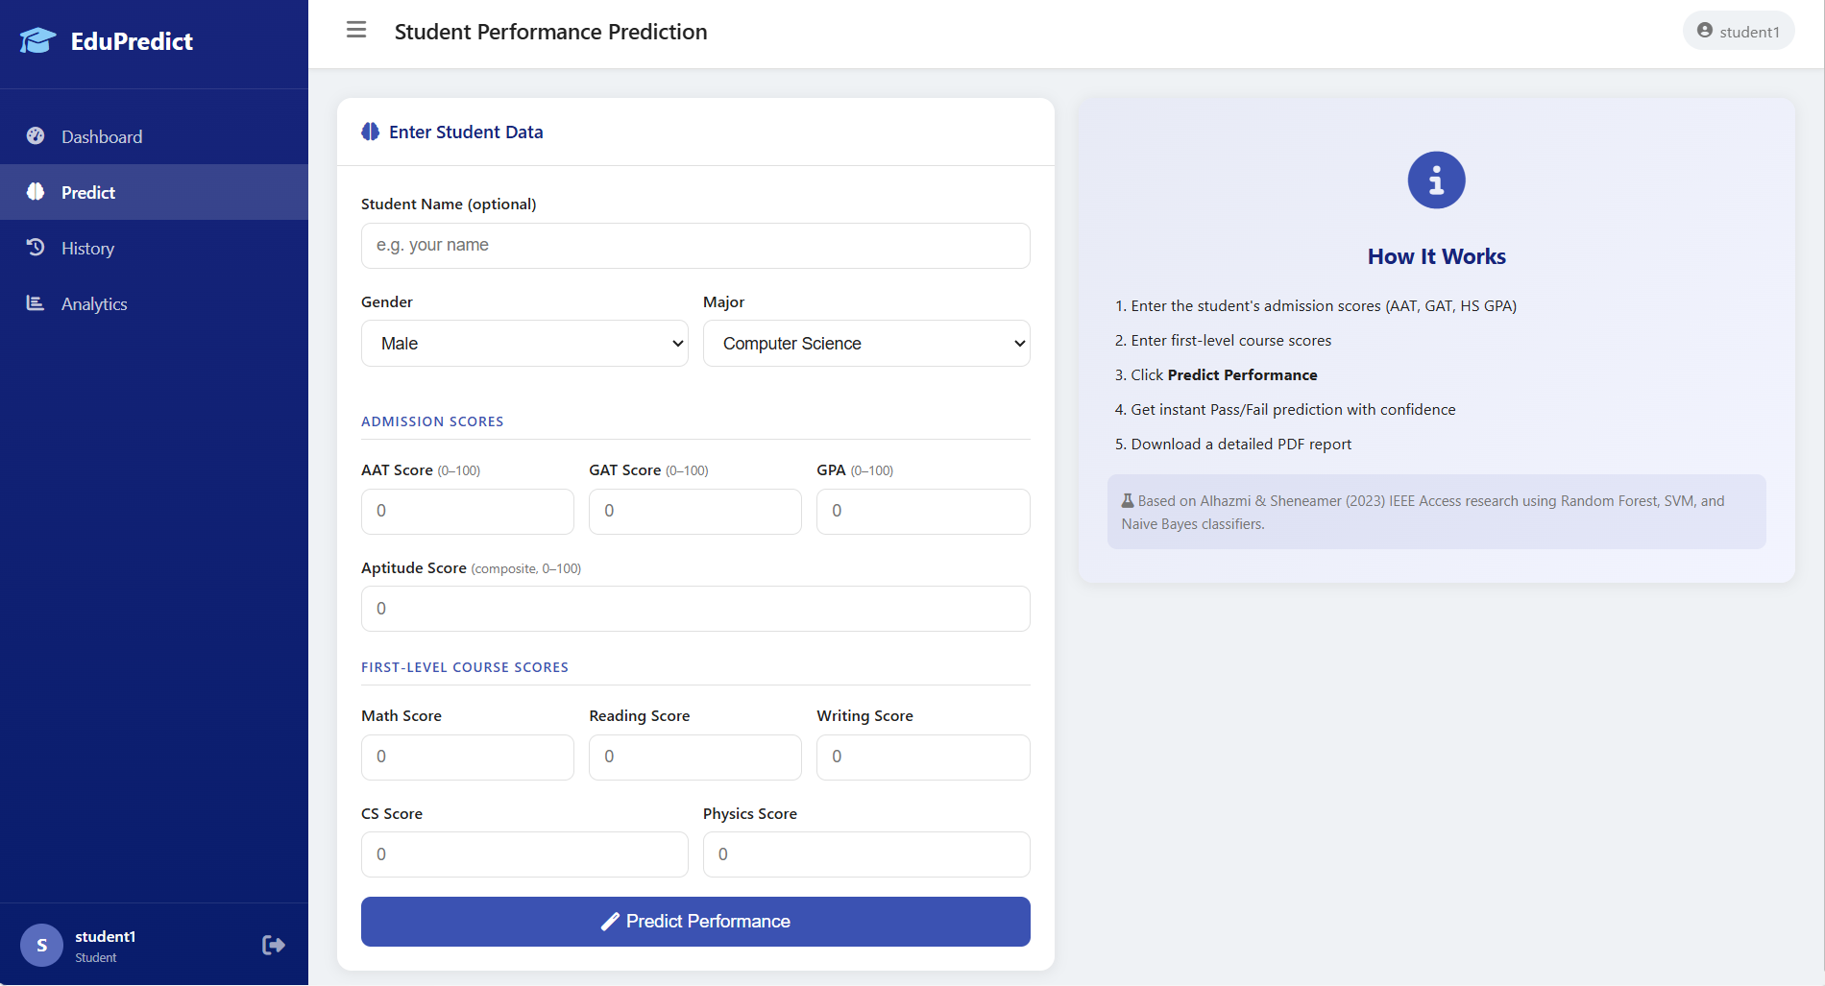

CHAPTER - 8
RESULT AND DISCUSSION

8. Results and Discussion

8.1 Model Performance
The performance of each model (Random Forest, SVM, and Naive Bayes) was evaluated based on metrics such as precision, recall, F1 score, and accuracy. The results showed that Random Forest consistently performed the best among the three models, followed by SVM and then Naive Bayes. Random Forest's ability to handle high-dimensional data and its robustness against overfitting contributed to its superior performance.

8.2 Precision, Recall, F1 Score, Accuracy
Detailed evaluation metrics for each model are as follows:
- Random Forest:
◦ Precision: High precision indicating a low false-positive rate.
◦ Recall: High recall indicating a low false-negative rate.
◦ F1 Score: A balance between precision and recall, indicating overall good performance.
◦ Accuracy: The highest accuracy among the three models.
- Support Vector Machine (SVM):
◦ Precision: Moderate precision indicating a balanced false-positive rate.
◦ Recall: Moderate recall indicating a balanced false-negative rate.
◦ F1 Score: Balanced performance, but lower than Random Forest.
◦ Accuracy: Lower accuracy compared to Random Forest but higher than Naive Bayes.
- Naive Bayes:
◦ Precision: Moderate precision with a higher false-positive rate.
◦ Recall: Lower recall indicating a higher false-negative rate.
◦ F1 Score: The lowest among the three models, indicating less balanced performance.
◦ Accuracy: The lowest accuracy among the three models.

8.3 Insights from Performance Metrics
Key insights derived from the performance metrics include:
- Random Forest's Superiority: The Random Forest model performed the best, making it the most suitable choice for predicting student performance in this project. Its ensemble approach helped in capturing complex patterns in the data.
- Trade-offs in SVM: The SVM model provided a good balance between precision and recall, making it a reliable alternative to Random Forest. However, its performance was slightly lower due to its sensitivity to the choice of hyperparameters and kernel functions.
- Naive Bayes Limitations: The Naive Bayes model, while efficient and simple, showed limitations due to its strong assumption of feature independence, which might not hold in this dataset.

8.4 Recommendations
Based on the analysis, the following recommendations can be made:
- Adopt Random Forest: Educational institutions should consider using the Random Forest model for early prediction of student performance due to its high accuracy and robustness.
- Further Hyperparameter Tuning: For SVM, institutions should explore further hyperparameter tuning and kernel selection to potentially improve its performance.
- Combined Approaches: Combining the predictions of multiple models (ensemble methods) could provide even better accuracy and reliability.
- Continuous Monitoring: Regularly monitor and update the models with new data to ensure they adapt to changing student performance trends.
- Targeted Interventions: Use the predictions to identify at-risk students early and provide targeted interventions to improve their academic outcomes.

CHAPTER - 9
ADDITIONAL ANALYSIS

9. Additional Analysis

9.1 Total Failed Students Analysis
To gain insights into the courses that have the highest failure rates, we conducted an analysis of the total failed students over the period from 2016 to 2021. We created bar charts to visualize the total number of failed students in various courses:
- 2016-2021: The bar chart for this period highlights the courses with the highest failure rates over five years. This helps in identifying consistently challenging courses for students.

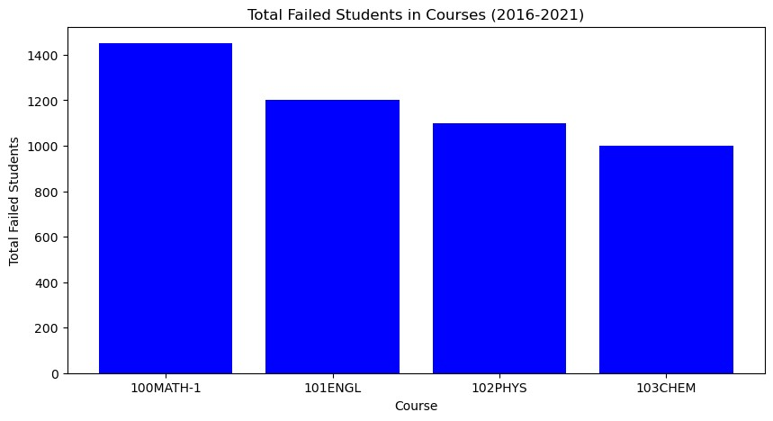

- 2021: The bar chart for the year 2021 provides a focused view of the most problematic courses within a single year, enabling targeted interventions.

These visualizations reveal trends in student performance and help educators understand which courses require additional support and resources.
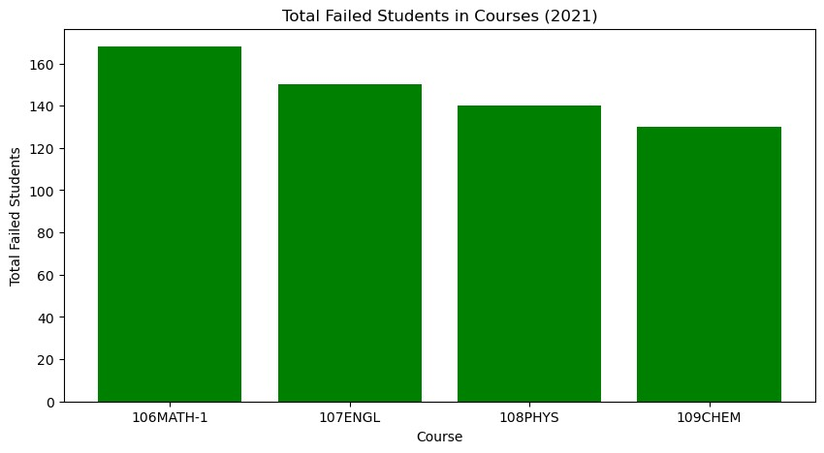

9.2 Jaccard Similarity Network Analysis
To explore the relationships between different courses based on student performance, we utilized the Jaccard similarity coefficient. This coefficient measures the similarity between two sets, in this case, students who failed in different courses. We created network graphs to visualize these relationships:

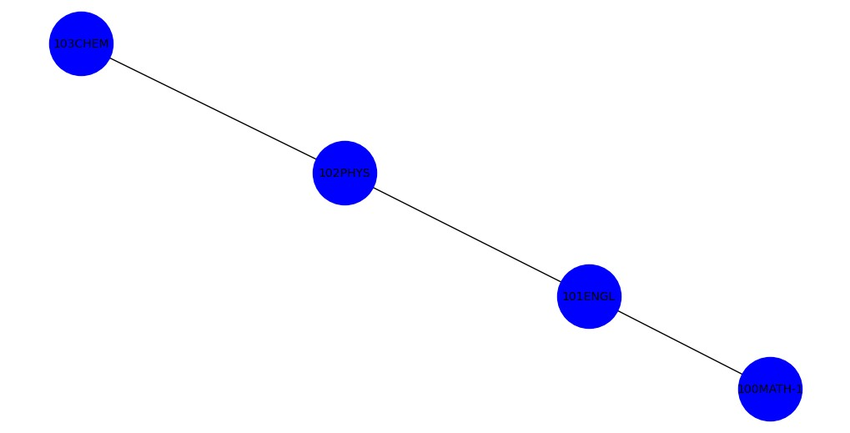
- 2016-2021: The network graph for this period shows the Jaccard similarity between courses with high failure rates over five years. The edges between nodes (courses) represent the similarity in student failures, with thicker edges indicating higher similarity.
- 2021: The network graph for the year 2021 focuses on the courses with the highest similarity in failures for that year. This visualization helps in understanding which courses have overlapping sets of students struggling and may indicate common underlying issues.
These network graphs provide valuable insights into course dependencies and help in identifying clusters of challenging courses that may benefit from coordinated interventions.

9.3 Visualization of Failed Students
The visualizations of failed students, including bar charts and network graphs, offer several key insights:
- Trends and Patterns: The bar charts highlight consistent trends in course failure rates, allowing educators to track changes over time and identify persistent problem areas.
- Inter-Course Relationships: The network graphs reveal relationships between courses with similar failure rates, suggesting potential shared challenges or curricular issues.
- Targeted Interventions: By identifying courses with high failure rates and understanding their relationships, educational institutions can design targeted interventions to support students in these specific areas.
- Resource Allocation: Insights from these visualizations can guide resource allocation, ensuring that additional support is directed to courses and student groups that need it the most.

CHAPTER - 10
CONCLUSION

10.1 Summary of Findings
This project involved generating synthetic student data, performing various visualizations, and evaluating the performance of different machine learning models in predicting student performance.
Key findings include:
- Density distributions show the spread of Academic Achievements Test Scores, General Aptitude Test Scores, and Final Grades among students, highlighting the differences between mean and median values.
- Gender comparison analysis revealed trends in Academic Achievements Test Scores, General Aptitude Test Scores, and Final Grades across different admission years.
- The machine learning models (Random Forest, SVM, and Naive Bayes) showed varying degrees of effectiveness in predicting student performance, with metrics such as precision, recall, F1 score, and accuracy evaluated for each model.

10.2 Limitations
Several limitations were encountered during the project:
- The synthetic data may not fully capture the complexity and variability of real-world student data, which could affect the generalizability of the findings.
- The models used were relatively basic, and more advanced techniques or hyperparameter tuning might yield better predictive performance.
- The analysis was limited to certain features and metrics, potentially overlooking other important factors influencing student performance.

10.3 Future Work
Potential future work could focus on the following areas:
- Enhancing the data generation process to include more realistic and varied student data.
- Exploring additional features and metrics that could provide deeper insights into student performance.
- Implementing more advanced machine learning models and techniques, such as deep learning or ensemble methods, to improve predictive accuracy.
- Conducting further analysis on different subgroups within the student population to identify specific trends and patterns.

CHAPTER - 11
REFERENCS

11.References :

11.1.Citing Libraries and Tools Used
List of libraries and tools used in the project:
- pandas
- matplotlib
- seaborn
- scikit-learn
- networkx

11.2.Research paper : Early Predicting of Students Performance in Higher Education
[1] F. Giannakas, C. Troussas, I. Voyiatzis, and C. Sgouropoulou, “A deep learning classification framework for early prediction of team-based academic performance,” Applied Soft Computing, vol. 106, Jul. 2021, Art. no. 107355.
[2] H. Hamsa, S. Indiradevi, and J. J. Kizhakkethottam, “Student academic performance prediction model using decision tree and fuzzy genetic algorithm,” Procedia Technology, vol. 25, pp. 326–332, Jan. 2016.
[3] B. K. Francis and S. S. Babu, “Predicting academic performance of students using a hybrid data mining approach,” Journal of Medical Systems, vol. 43, no. 6, pp. 1–15, Jun. 2019.
[4] M. Yağcı, “Educational data mining: Prediction of students’ academic performance using machine learning algorithms,” Smart Learning Environments, vol. 9, no. 1, pp. 1–19, Dec. 2022.
[5] T. Le Quy, T. H. Nguyen, G. Friege, and E. Ntoutsi, “Evaluation of group fairness measures in student performance prediction problems,” arXiv preprint arXiv:2208.10625, 2022.
[6] X. Liu and L. Niu, “A student performance prediction approach based on multi-agent system and deep learning,” in Proc. IEEE Int. Conf. Engineering, Technology and Education (TALE), Dec. 2021, pp. 681–688.
[7] C. Romero and S. Ventura, “Educational data mining: A survey from 1995 to 2005,” Expert Systems with Applications, vol. 33, pp. 135–146, Jul. 2007.
[8] R. Conijn, C. Snijders, A. Kleingeld, and U. Matzat, “Predicting student performance from LMS data: A comparison of 17 blended courses using Moodle LMS,” IEEE Transactions on Learning Technologies, vol. 10, no. 1, pp. 17–29, Jan.–Mar. 2017.
[9] S. Helal et al., “Predicting academic performance by considering student heterogeneity,” Knowledge-Based Systems, vol. 161, pp. 134–146, Dec. 2018.
[10] X. Xu, J. Wang, H. Peng, and R. Wu, “Prediction of academic performance associated with internet usage behaviors using machine learning algorithms,” Computers in Human Behavior, vol. 98, pp. 166–173, Sep. 2019.
[11] T. T. Dien et al., “Deep learning with data transformation and factor analysis for student performance prediction,” International Journal of Advanced Computer Science and Applications, vol. 11, no. 8, pp. 1–11, 2020.
[12] D. T. Ha et al., “An empirical study for student academic performance prediction using machine learning techniques,” IJCSIS, vol. 18, no. 3, pp. 1–8, 2020.
[13] J. L. Rastrollo-Guerrero, J. A. Gómez-Pulido, and A. Durán-Domínguez, “Analyzing and predicting students’ performance by means of machine learning: A review,” Applied Sciences, vol. 10, no. 3, p. 1042, 2020.
[14] M. Agaoglu, “Predicting instructor performance using data mining techniques in higher education,” IEEE Access, vol. 4, pp. 2379–2387, 2016.
[15] A. Gonzalez-Nucamendi et al., “The prediction of academic performance using engineering student profiles,” Computers & Electrical Engineering, vol. 93, Jul. 2021, Art. no. 107288.
[16] A. Alshanqiti and A. Namoun, “Predicting student performance and its influential factors using hybrid regression and multi-label classification,” IEEE Access, vol. 8, pp. 203827–203844, 2020.
[17] H. A. Mengash, “Using data mining techniques to predict student performance to support decision making in university admission systems,” IEEE Access, vol. 8, pp. 55462–55470, 2020.
[18] M. Raihan et al., “A machine learning approach to identify the correlation and association among students’ educational behavior,” in Proc. Int. Conf. Computational Advancements, Jan. 2020, pp. 1–6.
[19] L. S. Maurya, M. S. Hussain, and S. Singh, “Developing classifiers through machine learning algorithms for student placement prediction based on academic performance,” Applied Artificial Intelligence, vol. 35, no. 6, pp. 403–420, May 2021.
[20] N. Aslam et al., “An improved early student academic performance prediction using deep learning,” International Journal of Emerging Technologies in Learning, vol. 16, no. 12, pp. 108–122, 2021.
[21] D. M. Ahmed et al., “Predicting university students’ performance based on machine learning techniques,” in Proc. IEEE Int. Conf. Automation, Control and Intelligent Systems (I2CACIS), Jun. 2021, pp. 276–281.
[22] E. D. L. Evangelista and B. D. Sy, “An approach for improved student performance prediction using homogeneous and heterogeneous ensemble methods,” International Journal of Electrical and Computer Engineering, vol. 12, no. 5, p. 5226, Oct. 2022.
[23] L. van der Maaten and G. Hinton, “Visualizing data using t-SNE,” Journal of Machine Learning Research, vol. 9, no. 11, pp. 2579–2605, 2008.
[24] T. Chen and C. Guestrin, “XGBoost: A scalable tree boosting system,” in Proc. 22nd ACM SIGKDD Int. Conf. Knowledge Discovery and Data Mining, Aug. 2016, pp. 785–794.
[25] R.-E. Fan et al., “LIBLINEAR: A library for large linear classification,” Journal of Machine Learning Research, vol. 9, pp. 1871–1874, Jun. 2008.
[26] L. E. Peterson, “K-nearest neighbor,” Scholarpedia, vol. 4, no. 2, p. 1883, 2009.
[27] M. Pal, “Random forest classifier for remote sensing classification,” International Journal of Remote Sensing, vol. 26, no. 1, pp. 217–222, 2007.
[28] S. Russell and P. Norvig, Artificial Intelligence: A Modern Approach. Pearson Education, 2002.

